MEDIA SUMMARY
EMBARGOED UNTIL 12:01 A.M. 4/25/2017
CONTACT:
DAN MCGRATH, Daniel.McGrath@ed.gov, (202) 245-7548
GRADY WILBURN, Grady.Wilburn@ed.gov, (202) 245-8159
LISA MATTHEWS, LMatthews@hagersharp.com, (202) 706-7477

Eighth-Graders’ Arts Scores Remain Steady Since 2008
Nation’s Report Card also shows enrollment in arts courses is unchanged

Overall achievement in music and visual arts for the nation’s eighth-graders has remained the same since 2008, according to The Nation’s Report Card released today by the National Center for Educational Statistics (NCES).

Enrollment in arts courses and engagement in school arts activities remained unchanged for the nation’s eighth-graders between 2008 and 2016. The report also found that eighth-graders’ participation in the arts outside of school declined over the eight-year period.

The National Assessment of Educational Progress – also known as The Nation’s Report Card – is the only national assessment that measures what students know and can do in music and visual arts. The first assessment of student achievement in the arts was in 1997 and was administered for a second time in 2008.

This unique assessment measures students’ knowledge about the arts as well as their ability to create art. In 2016, NAEP assessed a national representative sample of approximately 8,800 eighth-graders attending public and private schools across the nation. The assessment challenged students to analyze and describe aspects of music they heard, critique instrumental and vocal performances, and demonstrate their knowledge of standard musical notation and music’s role in society. For the visual arts portion, students analyzed and described works of art and design. They were also required to create original works of art and design, including a self-portrait that was scored for identifying detail, compositional elements, and use of materials.

“The Nation’s Report Card paints a picture that shows eighth-graders continuing to take arts classes at the same rates and performing at the same levels as eight years ago,” said Peggy Carr, the acting commissioner of the National Center for Education Statistics. “We are noticing, however, that students are less likely to participate in activities such as taking art classes or playing a musical instrument outside of school.”

The national average scores in both music and visual arts remained the same as in 2008. In 2016, the average score in music was 147 and 149 in visual arts on NAEP’s scale of 0-300. Significant gaps remain between the different racial/ethnic groups, with some significant changes:

- In 2016, the White-Hispanic score gap narrowed in both music and visual arts compared to 2008.
- Asian and Pacific Islander students scored higher than White students overall in visual arts by eight points in 2016.
- The White-Black gap remained the same as in 2008 for both music and visual arts.

The 2016 results also showed that the gender gap remains, with female students outperforming their male peers in both music and visual arts.

Performance results for the 2016 arts assessment were also measured by school type. In both music and visual arts, scores for students in suburban schools were significantly higher than those in city schools, and scores for students in private schools were higher than those in public schools.
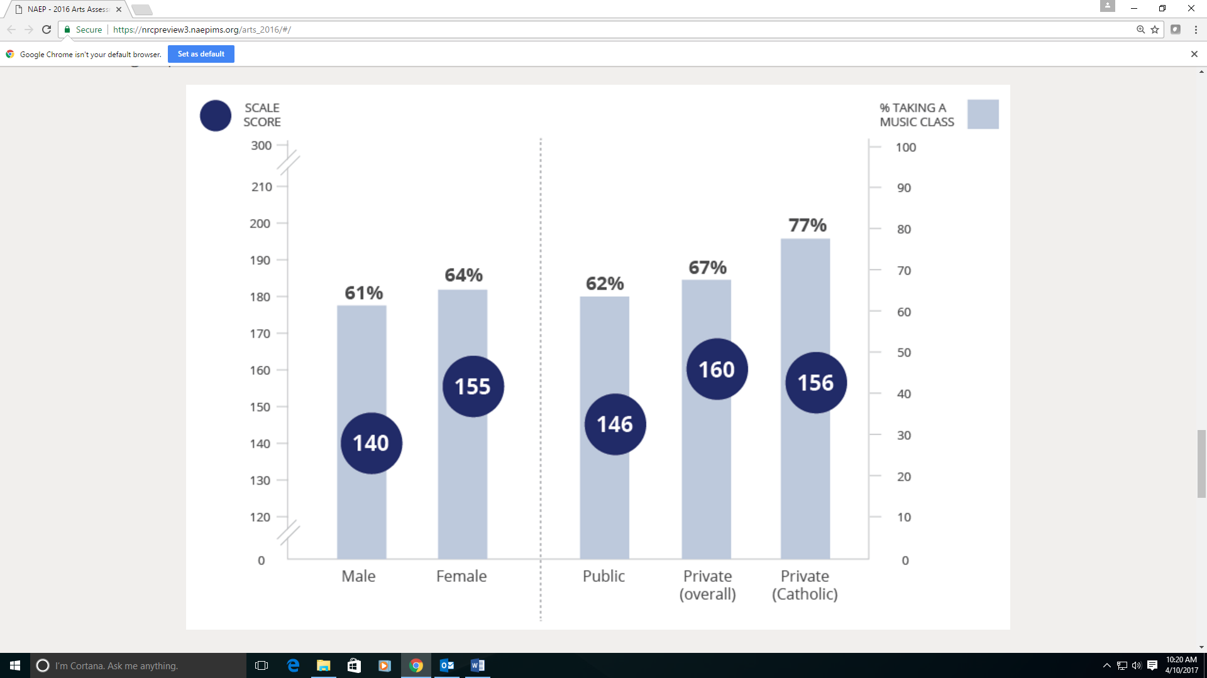
Average responding score of eighth-grade students assessed in music and the percentage of students who reported taking a music class in school, by selected student groups in 2016

In visual arts, students in the Northeast scored higher than their peers in other regions. In music, students in the Northeast only outperformed their peers in the West. In 2016, 68 percent of students in the Northeast reported taking an art course compared to 33 percent in the West, 35 percent in the South, and 47 percent in the Midwest.

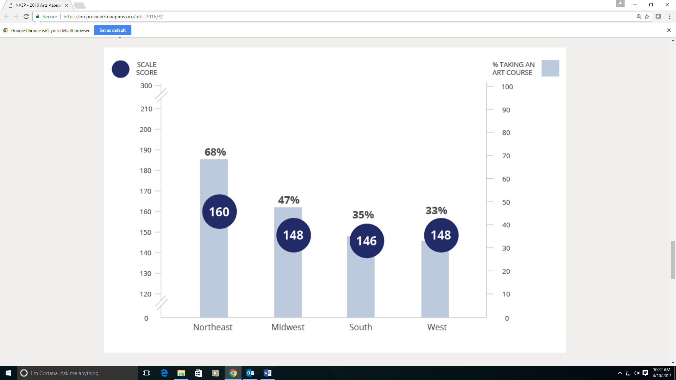
Average responding score of eighth-grade students assessed in NAEP visual arts and percentage of students who reported taking a visual arts course in school, by region of the country in 2016.

Visit https://nationsreportcard.gov/arts_2016/ to view the full report and learn more about the NAEP arts assessment.

###

The National Assessment of Educational Progress (NAEP) is a congressionally authorized project sponsored by the U.S. Department of Education. The National Center for Education Statistics (NCES), within the Institute of Education Sciences, administers NAEP. The Commissioner of the National Center for Education Statistics is responsible by law for carrying out the NAEP project.

NCES, a principal agency of the U.S. Federal Statistical System, is the statistical center of the U.S. Department of Education and the primary federal entity for collecting and analyzing data related to education in the U.S. and other nations. NCES fulfills a congressional mandate to collect, collate, analyze, and report complete statistics on the condition of American education; conduct and publish reports; and review and report on education activities internationally.

The National Assessment Governing Board (NAGB) is an independent, bipartisan board whose members include governors, state legislators, local and state school officials, educators, business representatives and members of the general public. Congress created the 26-member Governing Board in 1988 to set policy for NAEP. Since 1990, NAGB has been developing achievement levels, which are being used on a trial basis.

