EMBARGOED UNTIL 12:01 A.M. 10/27/16

MEDIA SUMMARY
EMBARGOED–HOLD FOR RELEASE UNTIL 12:01 A.M. 10/27/16
CONTACT:
DAN MCGRATH, Daniel.McGrath@ed.gov, (202) 245-7548
KELLÉ WYATT, KWyatt@hagersharp.com, (202) 706-7475

Science Scores Increased, Gaps Narrowed for Fourth- and Eighth-Grade Students

Nation’s Report Card shows grade 12 student scores unchanged since 2009

WASHINGTON— Fourth- and eighth-grade student performance in science improved since 2009, according to the Nation’s Report Card released today. Almost all racial/ethnic groups made gains, and the White-Black and White-Hispanic achievement gaps have narrowed in grades 4 and 8 since 2009. At grade 12, student performance results remained stable since 2009 for the nation overall and for all racial/ethnic groups.

In 2015, there was no statistically significant difference in average scores between boys and girls at grade 4. At grade 12, male students scored five points higher, on average, than female students; this gap has not changed significantly when compared to the gap from 2009.

“Science achievement since 2009 has improved for fourth- and eighth-grade students, and the gender gap has closed in grade 4 and narrowed at grade 8, while both boys and girls continued to make gains,” said Dr. Peggy Carr, acting commissioner of the National Center for Education Statistics (NCES). NCES administers the National Assessment of Educational Progress (NAEP), also known as the Nation’s Report Card.

“By contrast, achievement at grade 12 is unchanged, as are the gender and racial/ethnic gaps which have remained statistically significant since 2009.” Dr. Carr said. “One encouraging pattern we are observing is an increase in 12th grade students taking Biology, Physics and Chemistry in 2015 compared to 2009.”

The 2015 NAEP science results are the most recent results since 2009 for grades 4 and 12 and since 2011 for grade 8.

In addition to average scores, NAEP reports on the percentage of students performing at various achievement levels set by the National Assessment Governing Board (NAGB). The results in 2015 show that the percentages of students who performed at or above the NAEP Proficient level are greater at grade 4 than in 2009 and at grade 8 than in 2009 and 2011, but have remained the same at grade 12 since 2009. Twenty-two percent of high school seniors performed at or above Proficient in 2015.

Results are also available for the 46 states and the Department of Defense school system that volunteered to participate at grades 4 and 8 (no state-level data is available at grade 12). Compared to 2009, 18 states saw score increases, and one state declined, at grade 4. At grade 8, 24 states saw score increases while no states had score declines since 2009. Fifteen states/jurisdictions experienced significant score gains at both grades 4 and 8 compared to 2009. When looking at results from 2011 in grade 8, 12 states showed a score increase while one state showed a decline.

NAEP is the largest nationally representative and continuing assessment of what students in the United States know and can do in various subject areas. It is known as the “gold standard” of large-scale student assessments. Between January and March 2015, the NAEP science assessment was given to approximately 115,400 fourth-graders, 110,900 eighth-graders, and 11,000 twelfth-graders representing the nation’s public and private schools.

The science assessment is comprised of three content areas: physical science, Earth and space sciences, and life science. The NAEP scale for science scores range from 0-300. Student performance on NAEP is also reported by three achievement levels: Basic, Proficient, and Advanced. Proficient on the NAEP scale represents competency over challenging subject matter. You can find more information about what students can do at each achievement level by grade on the science assessment here: http://nces.ed.gov/nationsreportcard/science/achieve.aspx.

Grade 4
In 2015, the average score for fourth-grade students who took the NAEP science assessment was 154, a four-point increase from 2009. The percentage of students who performed at or above Proficient in 2015 was 38 percent, which is significantly different from 2009.

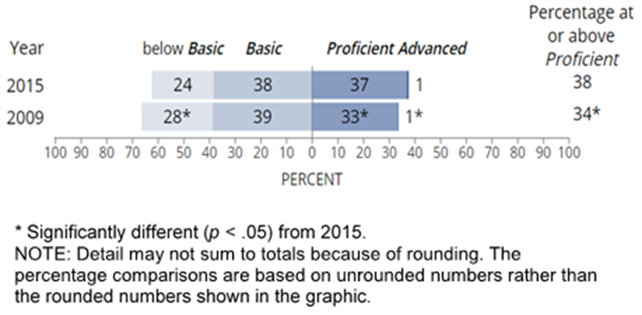

In 2015, the average score for White students was 166, 133 for Black students, 167 for Asian/Pacific Islander students, and 139 for both Hispanic and American Indian/Alaskan Native students. Average scores across all racial and ethnic groups saw significant increases since 2009.
More results at grade 4:
- In 2009, boys outperformed girls, on average, by approximately one point on the NAEP scale, but in 2015, the there was no gender gap.
- The average score gap between Black and White students decreased from 36 points in 2009 to 33 points in 2015.
- The difference in average scores between Hispanic and White students decreased from 32 points in 2009 to 27 points in 2015.
- Average scores increased in 18 states/jurisdictions and declined in one, compared to 2009.
- Fourth-grade students saw score improvements across all three content areas since 2009, scoring an average of 154 in physical science and life science, and 155 in Earth and space sciences.

Grade 8
In 2011, NAEP conducted a special administration of the science assessment at grade 8 to permit comparisons with the Trends in International Mathematics and Science Study (TIMSS). In 2015, eighth-grade students scored on average 154, a two-point increase from 2011 and four-point increase from 2009. The percentage of students who performed at or above Proficient in 2015 was 34 percent, an increase from 32 percent in 2011 and 30 percent in 2009. In 2015, the average scores for White and Asian students were 166, 132 for Black students, 140 for Hispanic students, 164 for Asian/Pacific Islander students, and 139 for American Indian/Alaska Native students.

Grade 8 Score Changes by Student Groups
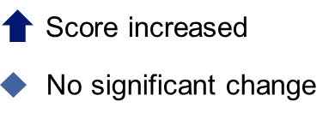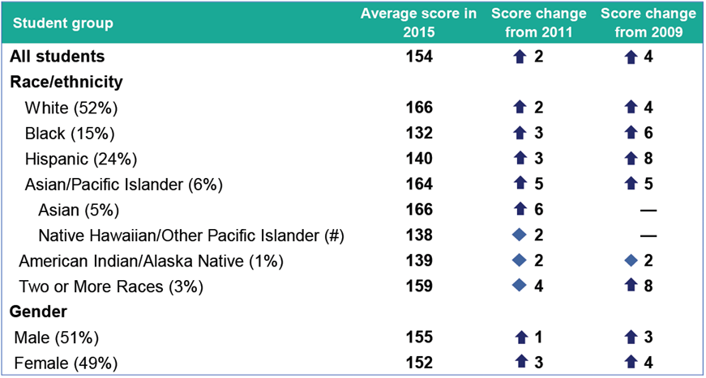
# Rounds to zero.
– Not available.
NOTE: Student group percentages in 2015 shown in parentheses. NAEP scale ranges from 0–300.

Other findings include:
- Male students scored higher on average than females with an average score of 155 compared to 152, and the score gap between male and female students has narrowed since 2011.
- The average score gap between Black and White students decreased from 36 points in 2009 to 34 points in 2015.
- The difference in average scores between Hispanic and White students decreased from 30 points in 2009 to 26 points in 2015.
- Compared to 2011, 2015 scores increased in 12 states/jurisdictions and declined in one.
- Compared to 2009, 2015 scores increased in 24 states/ jurisdictions; no states showed score declines.
- Eleven states experienced score increases from both 2009 and 2011.
- Eighth-grade students saw score improvements across all three content areas since 2009, scoring an average of 153 in physical science, 155 in life science, and 152 in Earth and space sciences.

Grade 12
The average score for twelfth grade students was 150, there were no significant changes overall compared to 2009. Twenty-two percent of high school seniors performed at or above Proficient, which is not significantly different than 2009. Forty percent of twelfth graders were below Basic, which has remained unchanged since 2009. There are no state level results for grade 12.

Male students outperformed their female peers by five points on average, which was not significantly different from the 6-point score gap in 2009. While male students scored higher on average than their female peers on the Earth and space sciences and physical science scales in 2015, there was no gender gap in life science. There were no significant changes in race and ethnic score gaps compared to 2009. In 2015, the score gap between White and Black students was 36 points, and 24 for White and Hispanic students.

Compared to 2009, grade 12 students were more likely to be taking a science course in 2015. Fifty-seven percent of twelfth-grade students reported enrollment in a science course, up from 53 percent in 2009. There was also a significant change in the percentage of students who reported having taken biology, chemistry, and physics in their high school careers; 41 percent of students reported having taken these courses in 2015 compared to 34 percent in 2009.

Full results for the nation and states are available online. For more information, visit
nationsreportcard.gov

###

The National Assessment of Educational Progress (NAEP) is a congressionally authorized project sponsored by the U.S. Department of Education. The National Center for Education Statistics (NCES), within the Institute of Education Sciences, administers NAEP. The Commissioner of the National Center for Education Statistics is responsible by law for carrying out the NAEP project.

NCES, a principal agency of the U.S. Federal Statistical System, is the statistical center of the U.S. Department of Education and the primary federal entity for collecting and analyzing data related to education in the U.S. and other nations. NCES fulfills a congressional mandate to collect, collate, analyze, and report complete statistics on the condition of American education; conduct and publish reports; and review and report on education activities internationally.

The National Assessment Governing Board (NAGB) is an independent, bipartisan board whose members include governors, state legislators, local and state school officials, educators, business representatives and members of the general public. Congress created the 26-member Governing Board in 1988 to set policy for NAEP. Since 1990, NAGB has been developing achievement levels, which are being used on a trial basis.

