NEWS RELEASE
EMBARGOED—HOLD FOR RELEASE UNTIL 12:01 A.M. April 27, 2016
CONTACT:
DAN MCGRATH, Daniel.McGrath@ed.gov, (202) 502-7426 OR
DAVID HOFF, dhoff@hagersharp.com, (202) 706-7430

The Nation’s Report Card Shows Mixed Results for Grade 12
Twelfth-grade students’ scores decline in mathematics, hold steady in reading from 2013
WASHINGTON—Average twelfth-grade mathematics scores are lower in 2015 than 2013, and the average score in reading has not changed during this time period according to The Nation’s Report Card released today. The national results are for both public and private school students.
The results also show that the scores of students at the tenth and twenty-fifth percentiles declined in both mathematics and reading from 2015 from 2013. The percentage of twelfth-grade students performing below Basic was higher in both subjects in 2015 compared to 2013. The percentage of twelfth-grade students performing at or above Proficient in mathematics and reading was not significantly different in 2015 compared to 2013. The score improved for twelfth graders at the ninetieth percentile in reading.
“Math scores have declined over the last two years at grade 12, mirroring the declines we saw at grades 4 and 8,” said National Center for Education Statistics (NCES) Acting Commissioner Peggy Carr. “We’re seeing that while lower performing students have score declines in both subjects, the highest performing students are making gains in reading.”
The National Assessment of Educational Progress (NAEP)—also known as The Nation's Report Card—is the largest nationally representative​ and continuing assessment of what students in the United States know and can do in various subject areas. It is known as the “gold standard” of large-scale student assessments.

NAEP is administered by the National Center for Education Statistics. Between January and March 2015, NAEP mathematics and reading assessments were administered to approximately 31,900 twelfth-graders in public and private schools representing all 50 states, the District of Columbia, and the U.S. Department of Defense. Participants were only assessed in one subject.
Mathematics Results
In 2015, the average scale score of all students who took the NAEP mathematics assessment was 152. This was a decrease from 2013, when the average scale score for all students was 153. Scores for both males and females declined. There was no significant difference in mathematics scores in 2015 from the first assessment year in 2005 for twelfth-graders in mathematics.

Average scores for twelfth-graders on NAEP mathematics assessment from first assessment year
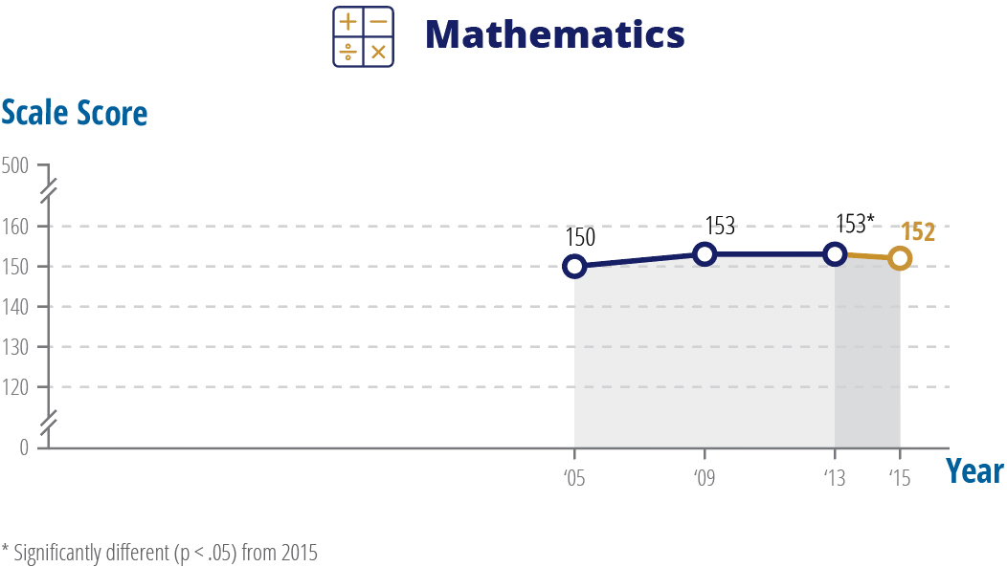
Student performance is reported using average scale scores, which range from 0 to 300 for mathematics, and 0 to 500 for reading, as well as achievement levels. There are three NAEP achievement levels: Basic, Proficient, and Advanced. Achievement levels are set by the National Assessment Governing Board. Proficient on the NAEP scale represents competency over challenging subject matter.
The percentage of students performing at or above Proficient has not changed significantly compared to 2013, nor compared to the first assessment year, 2005. In 2015, the percentage of students scoring below Basic increased to 38 percent (from 35 percent in 2013).
The Nation’s Report Card also reports data by various racial and ethnic groups. Compared to 2013, no significant change was seen in the 2015 average score for any racial/ethnic group. Compared to 2005, the first assessment year for mathematics, scores increased for White, Black, Hispanic, Asian/Pacific Islander students, and for students of two or more races.
Reading Results
Reading performance is presented in both scale scores (ranging from 0-500) and by achievement levels. In 2015, twelfth-grade students had an average reading score of 287, which was not significantly different from their score in 2013, but was lower than in 1992. Students at the 10th and 25th percentiles (the lowest achieving students) scored lower in 2015 compared to both 2013 and 1992.

Trend in twelfth-grade reading percentile scores
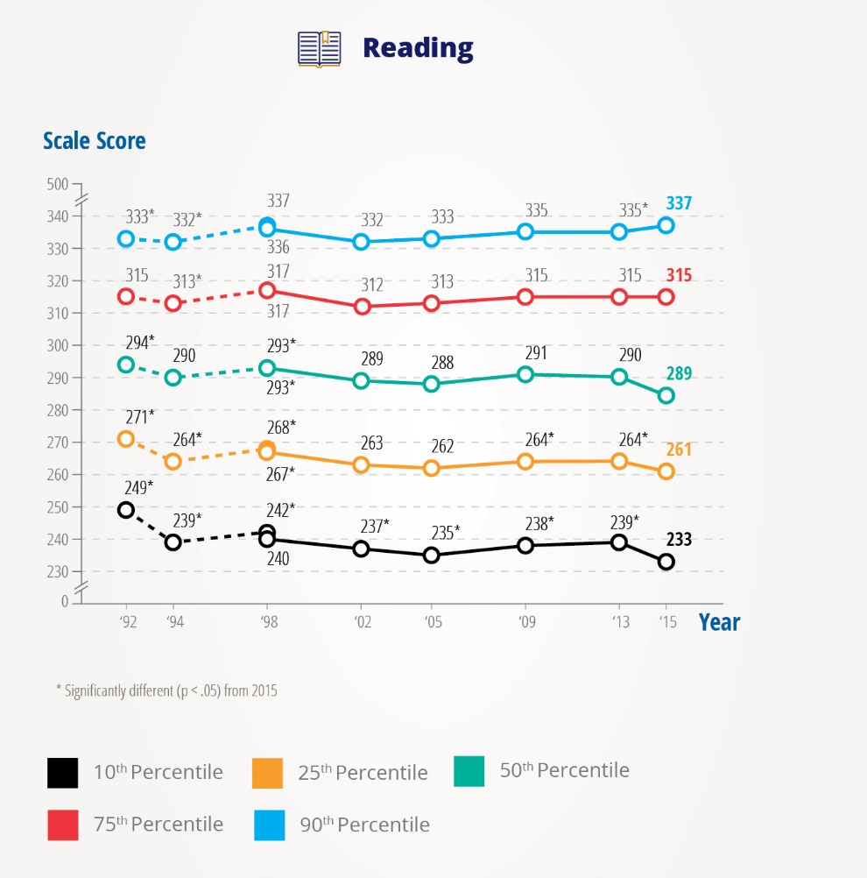

Thirty seven percent of twelfth-grade students scored at or above Proficient in reading in 2015, which was not significantly different from 2013, but was lower than in 1992. Six percent of students in 2015 scored at the Advanced level, an increase compared to 2013 and 1992.
There were no changes in the White-Black and White-Hispanic score gaps from 2013 to 2015.

Visit http://www.nationsreportcard.gov/reading_math_g12_2015/ to view the report.
###
The National Assessment of Educational Progress (NAEP) is a congressionally authorized project sponsored by the U.S. Department of Education. The National Center for Education Statistics (NCES), within the Institute of Education Sciences, administers NAEP. The Commissioner of the National Center for Education Statistics is responsible by law for carrying out the NAEP project.
The National Center for Education Statistics, a principal agency of the U.S. Federal Statistical System, is the statistical center of the U.S. Department of Education and the primary federal entity for collecting and analyzing data related to education in the U.S. and other nations. NCES fulfills a Congressional mandate to collect, collate, analyze, and report complete statistics on the condition of American education; conduct and publish reports; and review and report on education activities internationally.
The National Assessment Governing Board is an independent, bipartisan board whose members include governors, state legislators, local and state school officials, educators, business representatives and members of the general public. Congress created the 26-member Governing Board in 1988 to set policy for NAEP.

